**9/9/24 - project definition**

**9/10/24 - major components, block diagram, priorities**

## **9/9/24 - project definition**

***Project definition - Robotic Arm***

Objectives

* At least 3 axes
* Drawings / models:
  + 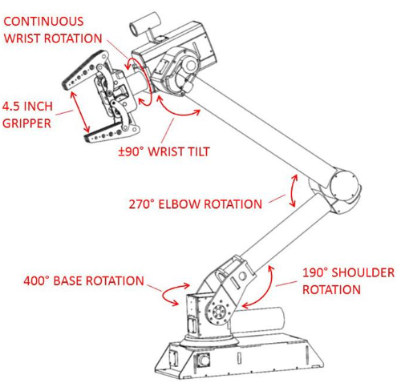
  + https://www.superdroidrobots.com/store/product=1902

User Interface

* User will have multiple buttons to interact with each of the arm’s axes

User Acceptance

* Given-When-Then criteria
  + Given: robot arm is in a certain position; each button refers to a rotatable axis of the arm
  + When: use presses, holds, and lets go of certain button
  + Then: a certain axis will start rotating, keep rotating, and then stop rotating

Technical

* Dimensions - around the length of average human arm
* Weight - less than 10 pounds; does not weigh down a wheelchair a significant amount
* Protection - should be tough enough to be bumped into enough; water resistant for outside capabilities

Functions

* User-operated robotic arm

Integration

* Adaptable to be put in various places

Environment

* Hazards of bumping into things
* Weather proof of being outside

Starting Point

* Existing IP
  + Kinova robotic arm

## **9/10/24 - major components, block diagram, priorities**

***Major components:***

* At least 3 motors, with potentially different rotational limits
* Controller for user input
* Microcontroller

***Block diagram:***

***Priorities:***

## **9/12/24 - component research**

[How To Make an Arduino Robotic Arm Controlled by Touch Interface](https://youtu.be/j-lX9l9-Di4?si=TKMM4JpMqP_dKPKA)

***Servos:***

* [Cheap Servo Demo - DS3218/PRO vs MG996R vs JX PDI-6208MG](https://youtu.be/mgHGVP5ZsPc?si=RdigkttQVh8wn-hy)
* MG996R
  + 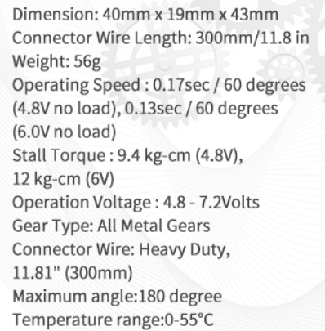
  + <https://www.amazon.com/6-Pack-MG996R-Torque-Digital-Helicopter/dp/B0BMM1G74B/ref=asc_df_B0BMM1G74B/?tag=hyprod-20&linkCode=df0&hvadid=692875362841&hvpos=&hvnetw=g&hvrand=9569021916595890122&hvpone=&hvptwo=&hvqmt=&hvdev=c&hvdvcmdl=&hvlocint=&hvlocphy=9003544&hvtargid=pla-2281435179578&mcid=895b588916e63ac8979880c805978872&hvocijid=9569021916595890122-B0BMM1G74B-&hvexpln=73&th=1>
* DS3218 / PRO
* JX PDI -6208 MG

9/25/24

Design document, containing:

* 1. Major Moving Parts of your design
  2. Sections / Block Diagram
  3. Priorities and Dependencies (can also be reflected in your tickets)
  4. Design approaches for your major moving parts
  5. Major component selection

1. Issues / tickets representing things that need to be done.
2. Make updates to your project definition as you go and discover new aspects.

You will not complete the entire design by next week. However, I need to be able to see you are actively working on each item and putting thought into it. Make honest attempts. Ask questions if you feel stuck.

As submission, put all your documents into your project's git repository and submit the link to that. Also link to the issue tracker / ticket system you are using. If you are using other tools like google docs, add links to that, too.

We’ll be using this repository:

<https://github.com/A-O24/Testing>